Contents

AZURE - NETWORKING 2

IP ADDESSS 2

IPv4 ADDRESSING 2

BINARY TO DECIMAL 2

CLASSES IN IP ADDRESSING 2

NETWORK ID IN IP ADDRESSING 3

PUBLIC IP ADDRESS 3

PRIVATE IP ADDRESS 4

DIFFERENCE BETWEEN PUBLIC VERSUS PRIVATE IP 4

SUBNETING 5

SUBNET, SUBNET MASK AND CIDR NOTATION 6

VIRTUAL NETWORK 6

COMPONENTS OF VNET 6

CREATING A VIRTUAL NETWORK 7

DEPLOYING A VM IN VIRTUAL NETWORKS 9

IP ADDRESS 10

VIRTUAL NETWORK INTERFACE 12

NETWORK SECURITY GROUP(NSG) 15

HOW NETWORK SECURITY GROUPS FILTER NETWORK TRAFFIC 18

COMMUNICATION WITH VIRTUAL NETWORKS 21

AZURE BASTION SERVICE 31

SETTING UP BASTION SERVICE 31

# AZURE - NETWORKING

## IP ADDESSS

* IP is the unique identifier of a device in a network.



|  |  |
| --- | --- |
|  | * The IP address has 2 parts * The Network part * Host part. * Each host in a network will have same Network Address |

### IPv4 ADDRESSING

|  |  |
| --- | --- |
| * It’s a 32-bit logical address * It consists of 4 octet – and each octet ranges from 0 -255 * IP address has parts ***Network ID and Host ID*** |  |

### BINARY TO DECIMAL

|  |  |
| --- | --- |
| * When the IP is represented in Binary the decimal representation can be done using the ***power to 2*** | * Hence the equivalent decimal will be 192.168.100.1 (128+64).(128 + 32 +8).(64+32+4).(1) |

## CLASSES IN IP ADDRESSING



* Ranges 127.x.x.x are reserved for the [loopback or localhost](https://www.computerhope.com/jargon/l/locahost.htm), for example, 127.0.0.1 is the loopback address.
* Range 255.255.255.255 [broadcasts](https://www.computerhope.com/jargon/b/broadcas.htm) to all hosts on the local network.

HOW TO DECIDE THE CLASS OF IP ADDRESS?

* To decide the class of IP address we consider the first octet for example – **132**.20.10.192 – This IP belong to CLASS B.

### NETWORK ID IN IP ADDRESSING

|  |  |  |  |  |
| --- | --- | --- | --- | --- |
| **CLASS** | **IP RANGE** |  | **NUMBER OF NETWORK** | **NUMBER OF HOST** |
| Class A |  | 1st 8 bits are Network Id  Remaining 24 bits are for Host | 126 | 224 = 16777216  16777216 – Network Id – Broadcast id =16777216 |
| Class B |  | 1st 16 bits are Network Id  Remaining 16 bits are for Host | 27 = 16,384 | 216 = 65536-2 = 65534 |
| Class C |  | 1st 24 bits are Network Id  Remaining 8 bits are for Host | 221 = 2,097,152 | 28 = 256-2 =254 |

|  |  |
| --- | --- |
|  | For the network part of the IP  For Class A - the 1st bit always “0”  For Class B - the 1st 2 bits always “10”  For Class C - the 1st 3 bits always “110”  CALCULATION OF NETWORK ID (EXAMPLE CLASS B)  Since the 1st 2 bits are always 1and 0 hence number of variable bits are 214 = 16384 |
|  | In the Host Part of IP. One Id is has been given to network ID and last Id will be broadcast ID |

### PUBLIC IP ADDRESS

|  |  |
| --- | --- |
|  | **WHAT IS A PUBLIC IP ADDRESS?**  A public IP address is an IP address that can be accessed directly over the internet and is assigned to your network router by the internet service provider (ISP). |

### PRIVATE IP ADDRESS

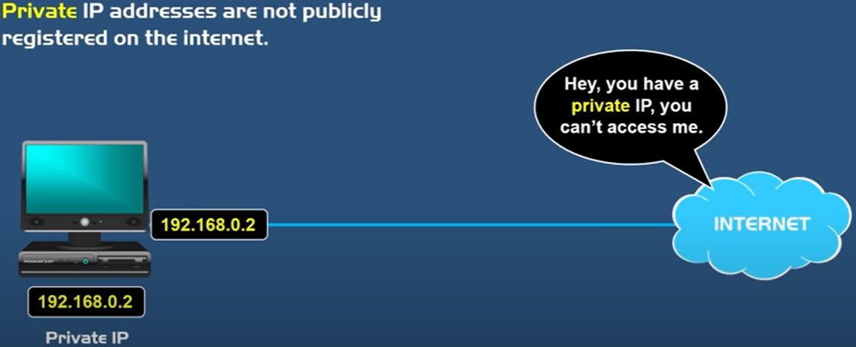

**WHAT IS A PRIVATE IP ADDRESS?**

* A private IP address is the address your network router assigns to your device. **Each device within the same network is assigned a unique private IP address** (sometimes called a private network address) — this is how devices on the same internal network talk to each other.
* Private IP addresses let devices connected to the same network communicate with one another without connecting to internet. This makes difficult for an external host to establish a connection, hence **private IPs help bolster security within a specific network**.
* **DHCP is a service used in the routers to assign private to the devices.**
* For all those devices in Home / office network- can access the internet only via public IP. The router assigns the private address of the device to public IP which we have been given by ISP(i.e. Router public IP address). ***The Service that does this translation of private to public and vice versa is called NAT (Network address translation). This servics are built-in the Router.***
* Reference: <https://www.youtube.com/watch?v=po8ZFG0Xc4Q>

**PRIVATE IP RANGE**

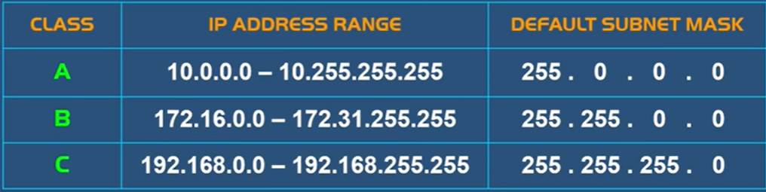

### DIFFERENCE BETWEEN PUBLIC VERSUS PRIVATE IP

|  |  |
| --- | --- |
| **PUBLIC IP ADDRESS** | **PRIVATE IP ADDRESS** |
| External (global) reach | Internal (local) reach |
| Used for communicating outside your private network, over the internet | Used for communicating within the private network, with other devices in your home or office |
| A unique numeric code never reused by other devices | A non-unique numeric code that may be reused by other devices in other private networks |
| Found by Googling: "What is my IP address?" | Found via your device’s internal settings |
| Assigned and controlled by your internet service provider | Assigned to your specific device within a private network |
| Not free | Free |
| Any number not included in the reserved private IP address range  Example: 8.8.8.8. | IP RANGE  10.0.0.0 — 10.255.255.255; 172.16.0.0 — 172.31.255.255;  192.168.0.0 — 192.168.255.255  Example: 10.11.12.13 |

### SUBNETING

* Subnet is a network withing a network.
* Subnetting is a concept of using the IP address effieciently

#### SUBNET MASK

|  |  |
| --- | --- |
|  | CALCULATION OF SUBNET MASK(CLASS A) |

#### CIDR NOTATION (CLASSLESS INTER DOMAIN ROUTING)

* CIDR gives the number of bits given to the network bit. For example, **192.168.100.1/24** This represent that the first 24 bits are used for network id. It is also called network pre-fix. Hence in a 32-bit IP address, 24 bits has been occupied by Network
* EXAMPLE: **205.150.65.0/26**

Conclusion from CIDR notation

1. The IP belongs to Class C
2. By default, in Class C - 24 bits are assigned to network and remaining 8 bits host. Hence the CIDR notation for Class C address in “24“
3. But in above example – since 2 more bits has been taken from Host. Hence the CIDR notation will be “26”

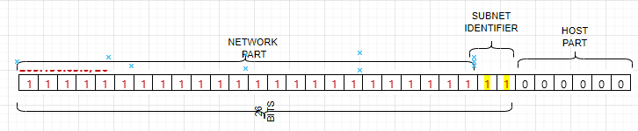

WHY WE DO THIS? – This help in subnetting.

#### SUBNETING CALCULATONS

Question: If Network Address Is – 205.150.65.0/26.

* **SUBNET MASK** 
  + Since it a class C IP. The default subnet mask is 255.255.255.0. But since we borrowed 2 more bits from the host bit hence the new subnet mask will be – 255.255.255.192 (*2^7 + 2 ^6 = 192*)
* **NETWORK ID**
  + It’s a logical AND operation of Network address and Subnet mask – **205.150.65.0**
  + **NUMBER OF POSSIBLE SUBNETS =** 2**(number of subnet identifier)** = 22 = 4 Subnets
  + **NUMBER OF POSSIBLE USABLE HOST (IN EACH SUBNET) =** 2**(number of host bits)** -2 = 26 -2 = 64-2 = 62 Hosts
    1. 2 is subtracted because 1st IP is reserved for Network and last IP for broadcast.
* **BROADCAST IPs (IN EACH SUBNET)**
  + This is the last IP in SUBNET. So, it will be
  + Broadcast Id for Subnet 0 - 205.150.65.63
  + Broadcast Id for Subnet 1 - 205.150.65.128
  + Broadcast Id for Subnet 2 - 205.150.65.192
  + Broadcast Id for Subnet 3 - 205.150.65.256

Question: If Network Address Is – 205.150.65.0/24. Create 10 Subnet from this network address

* This is a Class C IP address. If we have to create 10 subnets – Then we have to first decide how many bit, we will be borrowing from host bits. To create minimum 10 subnets, it will be 24 = 16 (4 bits we need to borrow to accommodate 10 subnets)

|  |  |
| --- | --- |
| SUBNET MASK | 255.255.255.240 |
| NETWORK ID | 205.150.65.0 |
| NO OF SUBNET | 24 = 16 Subnets |
| NO OF HOST (PER SUBNET) | 24-2 = 14 Hosts per subnet |
| BROADCAST ID | 205.150.65.15 |

### SUBNET, SUBNET MASK AND CIDR NOTATION

* Note the network id is represent by “1” and host is represented by “2”.

#### CALCULATING SUBNET MASK

* Example : Calculate the Subnet mask of : **115.10.10.20 ? Ans – 255.0.0.0**

##### WHAT IS THE JOB OF SUBNET MASK?

* Since the IP is consist of 2 parts - Network and Host part. Network Part in a network will be same for all host.
* Host decide the network Id with the help of Subnet Mask.
* Subnet mask is also of 32 bits -which has a mapping with the IP address. The 1s represent the network portion and 0s are the host portion. In the above example – When an IP is given to a device – then the subnet mask is also configured. The bits represented with “1” is the network id in the IP – when compared from left to right.

#### BROADCAST ID

* Broadcast IP is used to broadcast to all the host in the network.
* Find the class, network id, broadcast id and usable IP of the following IP

|  |  |
| --- | --- |
| **150.10.20.30** | * The IP belongs to Class B * Network Id: 150.10.0.0 * Broadcast ID: To calculate the broadcast id, set the host part of Network to 255. Hence the broadcast Id - 150.10.255.255 * Usable Host IP = Total Number of IP address – (Network IP + Broadcast IP) i.e.   + For a network there will be on Network IP and one Broadcast IP.   + Usable Host IP = Total IP -2= 216 – 2 = 65536 – 2= **65534** |

## VIRTUAL NETWORK

* Azure virtual network allow us to create an isolated /private network on cloud. Example- Any network created for Azure account will be solely dedicated for that account itself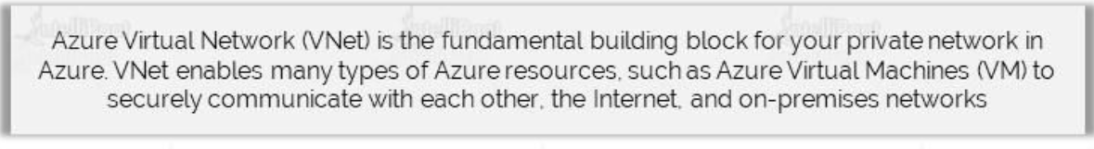
* <https://www.youtube.com/watch?v=feQvnIUJ3Iw>

### COMPONENTS OF VNET

|  |  |
| --- | --- |
| **ADDRESS SPACE** | * Address Space is the range of IP addresses * Azure will assign the next available IP address from the address space to the resources in the Virtual Network |
| **SUBNETS** | * A subnet is a logic segment of the Virtual network * A subnet is allocated a portion of a Virtual Network’s address space. |
| **REGION** | * Virtual Network are scoped to a single region * Multiple virtual networks from different region can be connected using VNET peering |
| **SUBSCRIPTION** | * Virtual Network are scoped to a subscription * We can implement multiple VNETs within each subscription and Azure region |

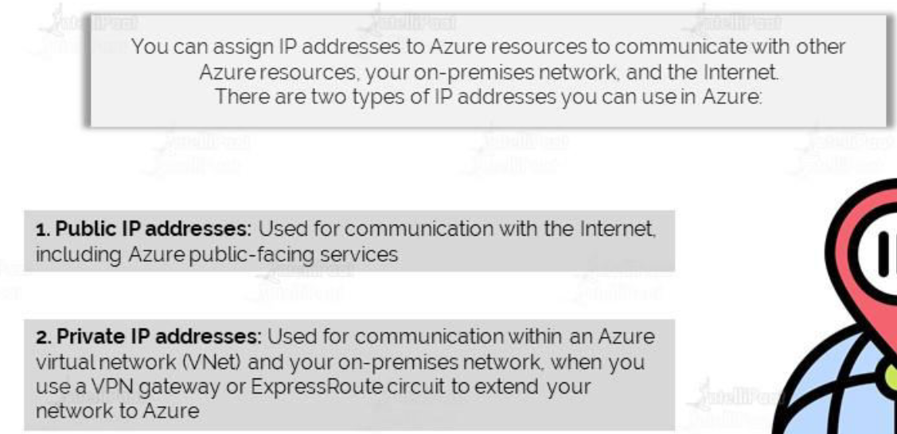

### CREATING A VIRTUAL NETWORK

* VNET creates a LAN – where all the associated resources get a private IP. Creating such private network help in managing the in and out traffic.
* When a VNET is created in Azure – by default it will have internet address- Hence all the associated VMs will have internet access as well, whether the VM has public IP or not.

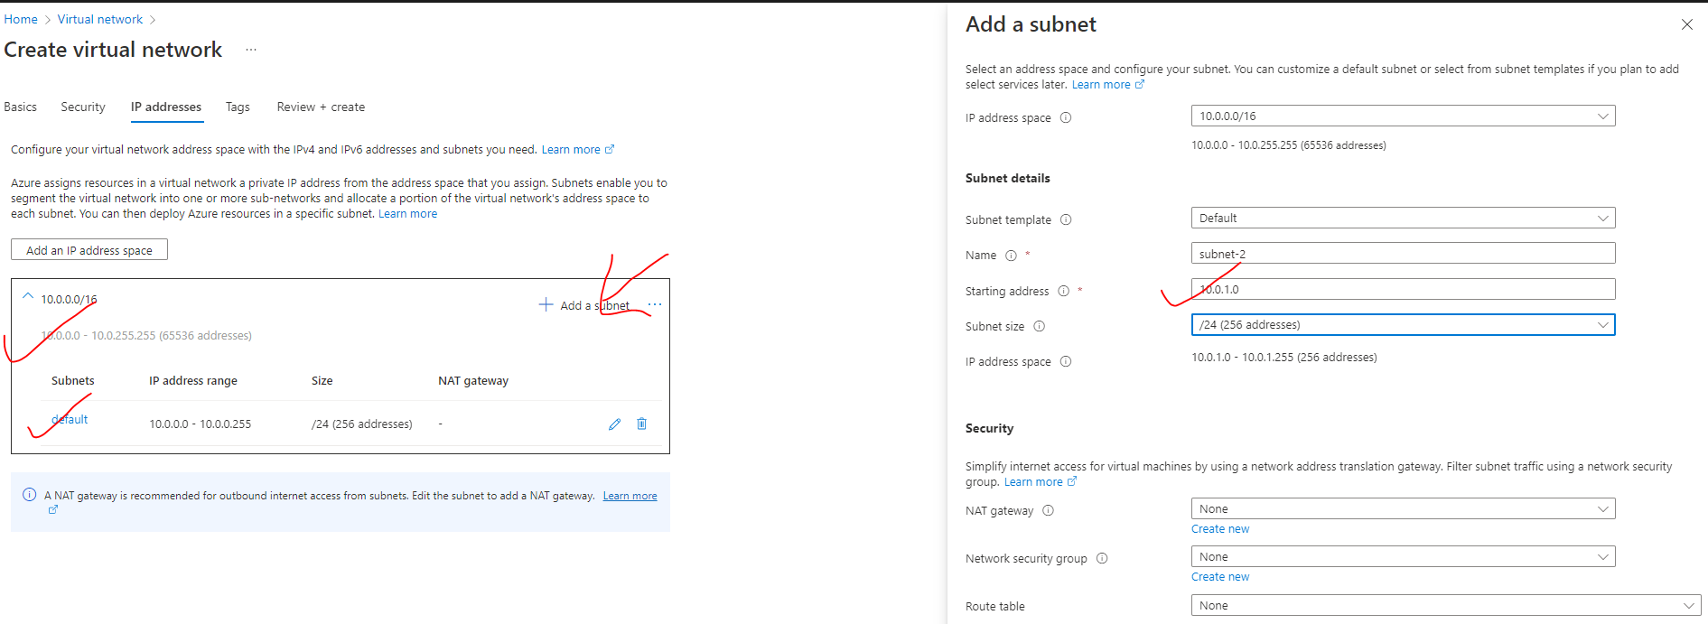

**IP ADDRESS**

* As per the above configuration (default configuration)- The VNET has 65536 addresses. Since VNET always set up a LAN in a region – hence all the IP will be Private IPs.
* By default, it creates a subnet of 10.0.0.0/24 – of 256 addresses.

**ADDING A NEW SUBNET**

* <https://www.davidc.net/sites/default/subnets/subnets.html?network=10.0.0.0&mask=20&division=23.f42331>
* When the subnet is created starting 5 addresses are reserved for
* **1 FOR DEFAULT GATEWAY**
* **2 FOR DNS**
* **1 FOR NETWORK ID (10.0.0.0)**
* **1 FOR BROADCAST (10.0.0.255)**
* Hence if the IP range of a subnet start from 10.0.0.0 , then the 1st VM will get the IP of 10.0.0.4

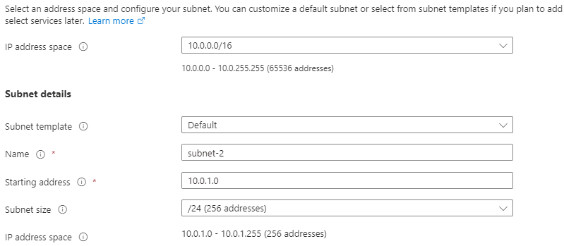

**SUBNET ADDED**

* As the IP is a Class A IP – hence

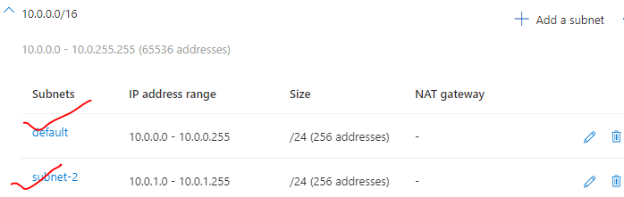

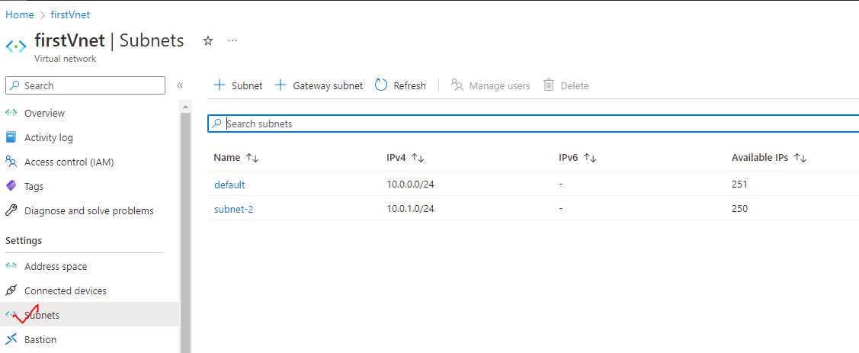

* The subnet can be deleted only if we don’t have any resource associated with a virtual network

|  |  |
| --- | --- |
|  | * The VM associated with different subnets within the VNET can be able to communicate with each other via their private IP. There is no need of public IP address for the communication with the VNET. * **This happens because Azure enables the routing, by default between the subnets** |

### DEPLOYING A VM IN VIRTUAL NETWORKS

* ***To associate a VM to a given virtual network. The virtual machine must be created in in the same region as of VNET.***
* In the below example –while creating the VM, we are selecting a subnet – 10.0.1.0/24. The first VM will get the private IP of 10.0.0.4 (first 5 Ips are reserved for default gateway -1, network id -1, broadcast id -1, DNS- 2)

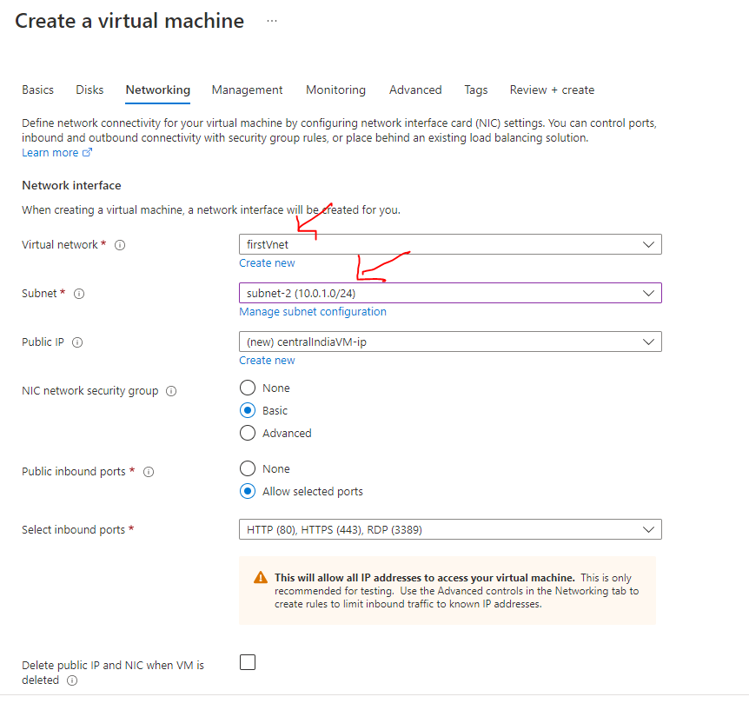

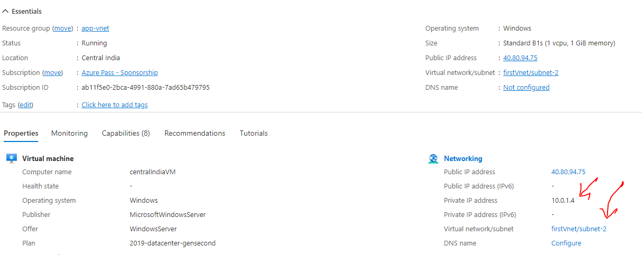

* The VM will show up as a Connected device in the Virtual network.
* Note – Until a VM is connected to a subnet – the subnet cannot be deleted from the VNET.

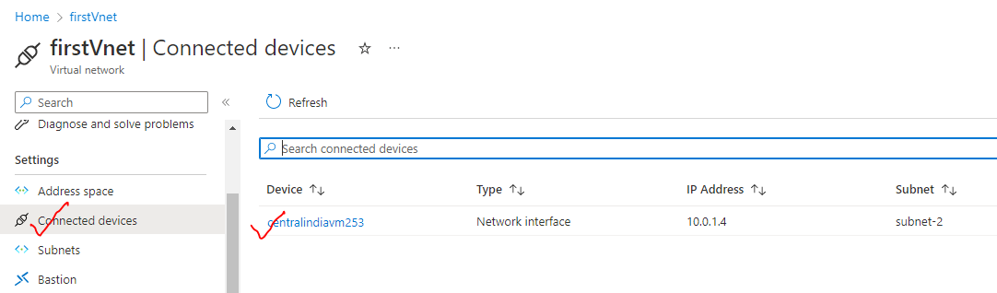

### IP ADDRESS

* We can assign IP address to Azure resource to communicate with other Azure resources.

|  |  |
| --- | --- |
| **PUBLIC IP** | * Used for the communication within the internet , including Azure public facing services |
| **PRIVATE IP** | * Used for the communication within the Azure VNET and On-Premise Network, when we use a VPN gateway or ExpressRoute circuit to extend network in Azure * A private IP address is assigned to the resource in VNET. The addresses are assigned from the address pool range of VNET. * The resources can be able to communicate with each other using their private IP address. |

#### IP ADDRESS ALLOCATION METHODS

There are 2 methods of IP address allocation

|  |  |
| --- | --- |
| DYNAMIC ALLOCATION | * Azure assigns the next available unassigned or unreserved IP address in subnet’s address range * When a public address needs to be assigned to an Azure resource. It is dynamically allocated from the pool of available address within the location the resource is created. |
| STATIC ALLOCATION | * We assign the available unassigned or unreserved IP address in subnet’s address range * Private IP address can eb allocated with either Dynamic and Static allocation |

##### STATIC IP ADDRESS

|  |  |
| --- | --- |
|  | * When we create and associate a VM, it gets a public IP address and private IP address. All of these are dynamic IPs. * When we stop and the start the VM, it will get allocated with a new public IP address * This can be an issue when, let's say that we have a Web application hosted on the VM. To make it accessible to the user using some DNS (e.g., **cloudportalhub.com**), the external DNS provider map the domain name with the public IP address of the VM. * If the VM is stopped and started again, the IP address the changes and if the IP address changes, this link is broken so users will not be able to reach the application. * To mitigate this issue, we can allocate a static IP address to both the public IP and private IP address. |

###### ASSIGNING STATIC IP ADDRESS

To assign static IP address to a VM

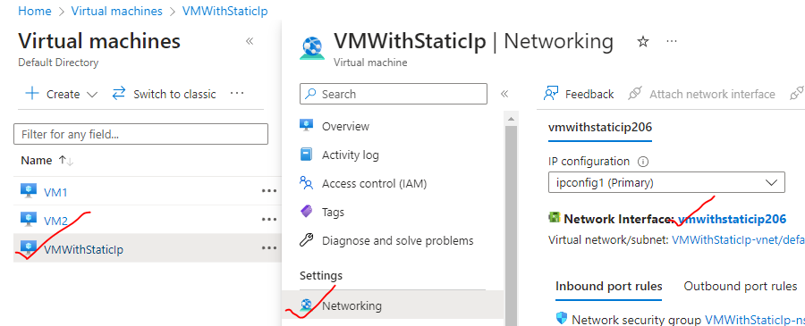

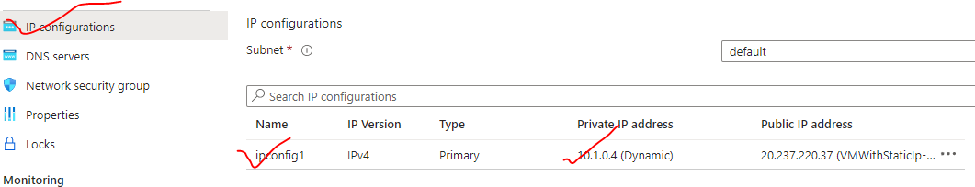

* Since it an static IP address – We can assign an available IP addess manually (from the address pool of the VNET)

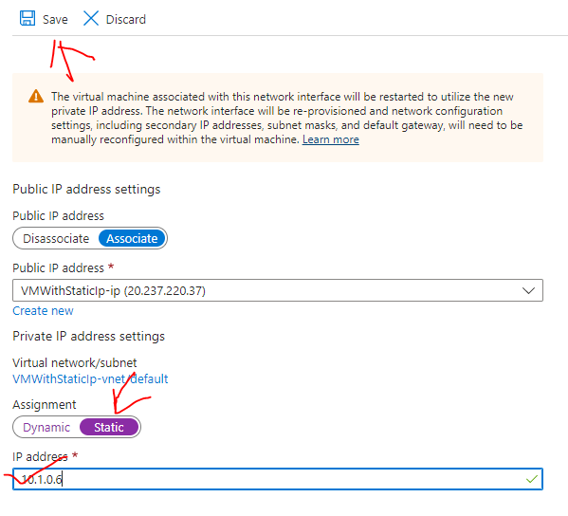

STATICALLY ASSIGNED IP ADDRESS TO A VM

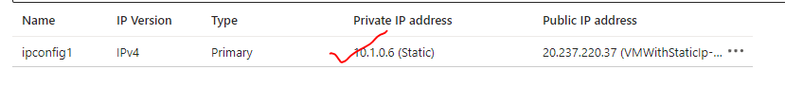

### VIRTUAL NETWORK INTERFACE



|  |  |
| --- | --- |
|  | * The network interface is a physical device is used as an interface between the machine (VM) and Network (VNET). In Azure, the VMs are the cloud, they are known as a ***virtual network interface***. * *Any device (Physical or Virtual) which need to connect to internet needs a Network Interface Card (It can be wired or wireless).* ***Every VM in Azure has virtual network interface that is attached to it by default****. It gets assigned to VM while creating a VM itself.* * **The NIC are then attached to VNET/Subnet** * A VM must have one NIC - but more NIC can also be attached VM-depending upon on the size of the VM itself. |

* THE VIRTUAL NETWORK INTERFACE CARD GETS BOTH **PRIVATE AND PUBLIC IP ADDRESS**

|  |  |
| --- | --- |
| PRIVATE IP ADDRESS | PUBLIC IP ADDRESS |
| * The private IP of VNI is used for the communication within the VNET. * The private IP lies in the range of Subnet of which the VM is part of | * The public IP is used for the communication on internet * This is assigned by Azure itself |

#### DEFAULT VIRTUAL NETWORK INTERFACE OF VM

* A default VNIC get attached to a VM during its creation. The VNIC has both private and public IP

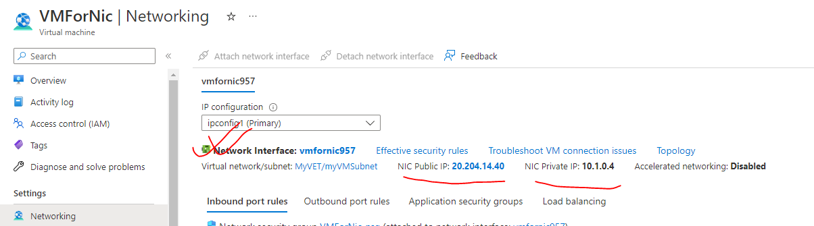

VNIC PROPERTIES

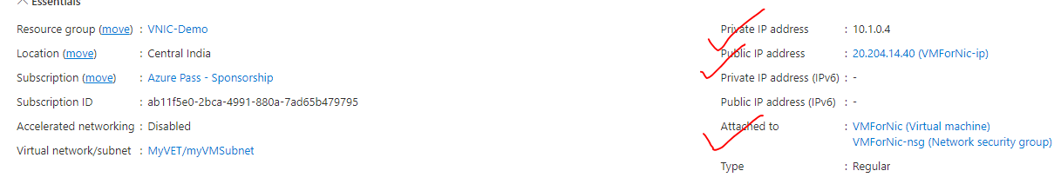

#### SECONDARY VIRTUAL NETWORK INTERFACE

* By default, the VM has a Virtual Network Interface attached to it – But we can attach a secondary VNI to a VM

##### CREATING A SECONDARY VIRTUAL NETWORK INTERFACE

ADDING A SECONDARY V-NIC

|  |  |
| --- | --- |
|  | **WHY WE NEED A SECONDARY VNI?**   * + When a VM is created – it is attached to a default subnet within a Virtual Network.   + The V-NIC help in the communication of VM with the subnet   + Adding a secondary NIC to a VM helps the VM to connect with another subnet within the Virtual network.   The |
|  | **USE-CASE**   * + Let’s say we have traffic coming from Backend and front end.   + We can have secondary subnet for each traffic to avoid network congestion |

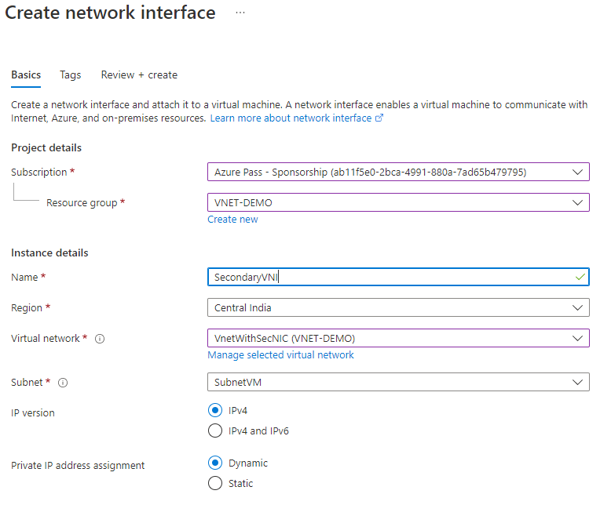

ATTACH VNIC TO VM

|  |  |
| --- | --- |
|  | * + ***To attach a Network interface to a VM – we need to first STOP the VM(Deallocated)***   + We can connect network interfaces in the same VM to different subnets within a virtual network. However, the network interfaces must all be connected to the same virtual network. |
|  |

### NETWORK SECURITY GROUP(NSG)

|  |  |
| --- | --- |
|  | 1. A NSG is used to filter incoming and outgoing traffic to and from several types of Azure Resources. 2. The purpose of network security groups is to manage (Deny/ Allow) the traffic that's coming in and going out of Azure Resources 3. NSG is separate resource in Azure 4. It has rules for inbound (coming into the VM) and outbound (going out of the VM) traffic. Note -By default, there is no inbound rule to allow traffic from the internet. 5. We can have multiple NSG rules, which has the priority associated with it. The rules are evaluated in the order of the priority. |

#### NETWORK SECURITY GROUP OVERVIEW

|  |  |
| --- | --- |
| NSG-processing | * NOTE – the NSG can be applied on 2 level  1. AT THE SUBNET LEVEL OF WHICH THE VM IS PART OF – (This takes high priority) 2. AT THE NETWORK INTERFACE CARD LEVEL OF THE VM |

#### SETTING UP NSG FOR A VM ON NIC LEVEL

* **STEP 1: CREATE A VM** – While creating a VM (in Basic and Networking tab we have setting available for NSG)– we set some “inbound port rules”- the actually creates an inbound NSG rule for the given VM

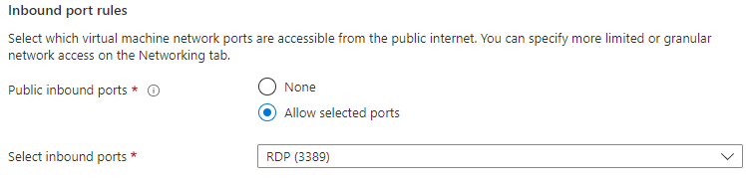

The NSG is a separate resource in Azure VM. In the below image – we can see that

* The NSG can be viewed in Networking section of the VM
* The NSG has both Inbound and outbound rules for the traffic
* The NSG are attached to the NIC (Network interface). Note – we can also attach the NSG to the subnet (of which VM is part of) as well

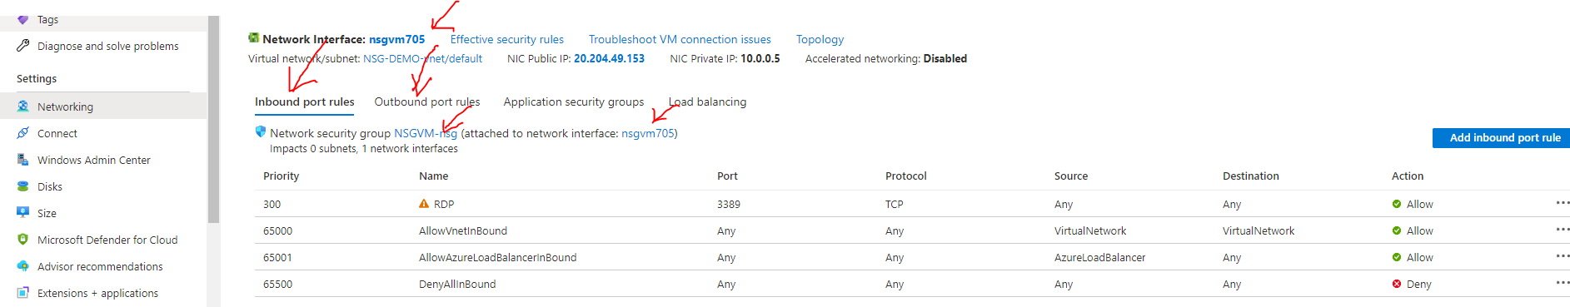

##### NSG RULES

DEFAULT NSG RULES

* By default, NSG has some default inbound and outbound NSG rules. We cannot change the default NSG rules.

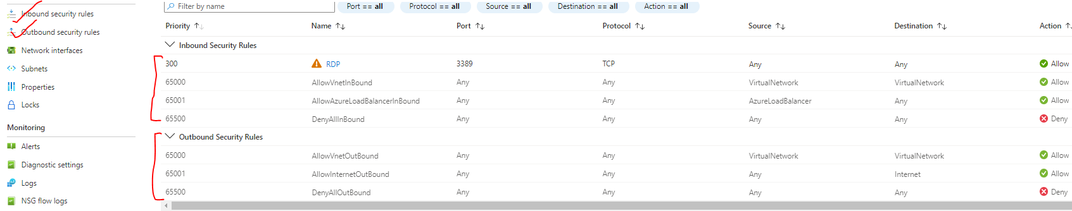

|  |  |
| --- | --- |
|  | **USE CASE FOR NSG**   * Let’s say we have IIS installed on VM – which we want to allow the access from any machine. * For this we need to add a NSG rule (inbound – as it’s an inbound traffic) |

##### PRIORIRY SETTINGS IN NSG RULES

| PROPERTY | EXPLANATION |
| --- | --- |
| **NAME** | * A unique name within the network security group. |
| **PRIORITY** | * A number between **100 and 4096.** Rules are processed in priority order, with lower numbers processed before higher numbers, hence **lower numbers have higher priority**. * Once traffic matches a rule, processing stops. As a result, any rules that exist with lower priorities (higher numbers) that have the same attributes as rules with higher priorities aren't processed. |
| **SOURCE OR DESTINATION** |  |
| **PROTOCOL** | * TCP, UDP, ICMP, ESP, AH, or Any. The ESP and AH protocols aren't currently available via the Azure portal but can be used via ARM templates. |
| **DIRECTION** | * Whether the rule applies to inbound, or outbound traffic. |
| **PORT RANGE** | * We can specify an individual or range of ports. |
| **ACTION** | * Allow or deny |

* THE RULES ARE EXECUTED FROM TOP TO BOTTOM
* **IF THE CONDITION IS MEET FOR A CONFIGURED RULE – NO FURTHER RULES ARE EVALUATED**

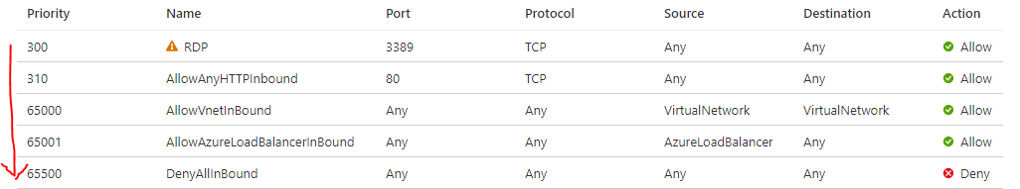

* *Example - In the below rules the Inbound to PORT 80 is denied. As the port “80” comes in the range of 50-100. Now once the rules in matched – no further evaluation of rules will be processed*

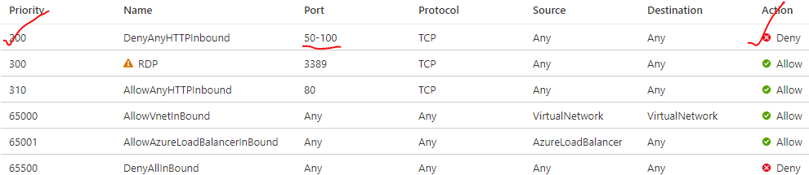

#### SETTING UP NSG FOR A VM ON SUBNET LEVEL

* As the NSG rules can be applied to NIC and Subnet level (Subnet of which the VM is part of). In this case the NSG rule at subnet level will be evaluated first for NIC rules.

**TO CONFIGURE NSG ON SUBNET LEVEL**

Step 1: CREATE AN NSG –

* NSG is a separate resource in Azure. The NSG must be created in the same region of Virtual Network of the Virtual Machine.

|  |  |
| --- | --- |
| VNET OF THE VM |  |

Step 2: NAVIGATE TO THE NSG AND ASSOCIATE THE SUBNET

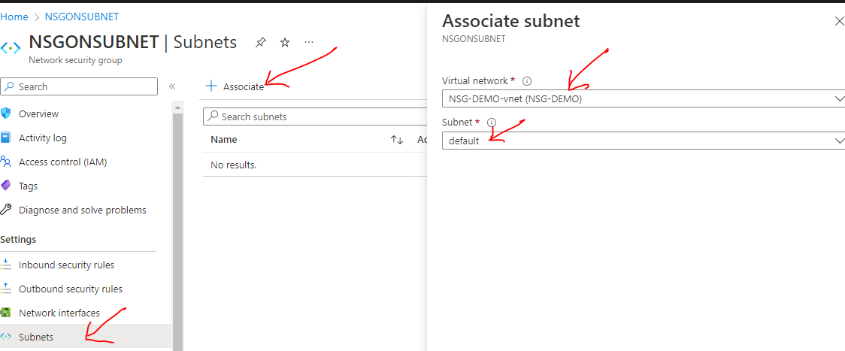

Step 3: RULES ON SUBNET LEVEL

* After the newly created rules is attached to the VM’s subnet. This gets evaluated first
* In the below rules – there is no rule for “80” PORT hence the request for the service running on “80” will be denied

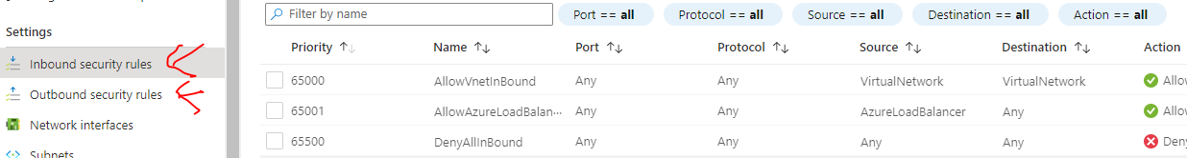

Step 4: ADDING A RULE ON SUBNET LEVEL

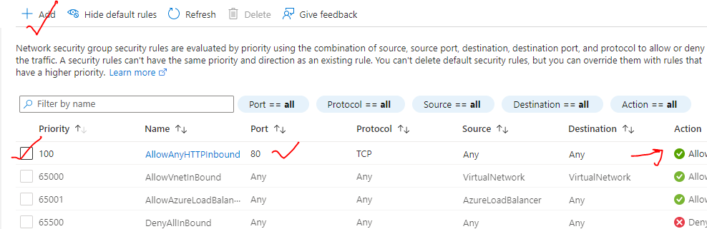

#### HOW NETWORK SECURITY GROUPS FILTER NETWORK TRAFFIC

* We can use an Azure network security group to filter network traffic to and from Azure resources in an Azure virtual network. A network security group contains [security rules](https://learn.microsoft.com/en-us/azure/virtual-network/network-security-groups-overview#security-rules) that allow or deny inbound network traffic to, or outbound network traffic from, several types of Azure resources. For each rule, we can specify source and destination, port, and protocol.
* We can associate zero, or one, network security group to each virtual network [subnet](https://learn.microsoft.com/en-us/azure/virtual-network/virtual-network-manage-subnet#change-subnet-settings) and [network interface](https://learn.microsoft.com/en-us/azure/virtual-network/virtual-network-network-interface#associate-or-dissociate-a-network-security-group) in a virtual machine. The same network security group can be associated to as many subnets and network interfaces as we choose.

|  |  |
| --- | --- |
| NSG-processing | The following picture illustrates different scenarios for how network security groups might be deployed to allow network traffic to and from the internet over TCP port 80: |

##### INBOUND TRAFFIC

**For inbound traffic, Azure processes the rules in a network security group associated to a subnet first, if there's one, and then the rules in a network security group associated to the network interface, if there's one. This includes intra-subnet traffic as well.**

1. **VM1**: The security rules in NSG1 are processed since it's associated to Subnet1 and VM1 is in Subnet1. Unless you've created a rule that allows port 80 inbound, the traffic is denied by the [DenyAllInbound](https://learn.microsoft.com/en-us/azure/virtual-network/network-security-groups-overview#denyallinbound) default security rule, and never evaluated by NSG2, since NSG2 is associated to the network interface. ***If*NSG1*has a security rule that allows port 80, the traffic is then processed by*NSG2*. To allow port 80 to the virtual machine, both*NSG1*and*NSG2*must have a rule that allows port 80 from the internet.***
2. **VM2**: The rules in NSG1 are processed because VM2 is also in Subnet1. Since VM2 doesn't have a network security group associated to its network interface, it receives all traffic allowed through NSG1 or is denied all traffic denied by NSG1. Traffic is either allowed or denied to all resources in the same subnet when a network security group is associated to a subnet.
3. **VM3**: Since there's no network security group associated to Subnet2, traffic is allowed into the subnet and processed by NSG2, because NSG2 is associated to the network interface attached to VM3.
4. **VM4**: Traffic is allowed to VM4, because a network security group isn't associated to Subnet3, or the network interface in the virtual machine. All network traffic is allowed through a subnet and network interface if they don't have a network security group associated to them.

##### OUTBOUND TRAFFIC

***For outbound traffic, Azure processes the rules in a network security group associated to a network interface first, if there's one, and then the rules in a network security group associated to the subnet, if there's one. This includes intra-subnet traffic as well.***

1. **VM1**: The security rules in NSG2 are processed. Unless you create a security rule that denies port 80 outbound to the internet, the traffic is allowed by the [AllowInternetOutbound](https://learn.microsoft.com/en-us/azure/virtual-network/network-security-groups-overview#allowinternetoutbound) default security rule in both NSG1 and NSG2. If NSG2 has a security rule that denies port 80, the traffic is denied, and never evaluated by NSG1. ***To deny port 80 from the virtual machine, either, or both network security groups must have a rule that denies port 80 to the internet***.
2. **VM2**: All traffic is sent through the network interface to the subnet, since the network interface attached to VM2 doesn't have a network security group associated to it. The rules in NSG1 are processed.
3. **VM3**: If NSG2 has a security rule that denies port 80, the traffic is denied. If not, the traffic is allowed by the [AllowInternetOutbound](https://learn.microsoft.com/en-us/azure/virtual-network/network-security-groups-overview#allowinternetoutbound) default security rule in NSG2, since a network security group isn't associated to Subnet2.
4. **VM4**: All network traffic is allowed from VM4, because a network security group isn't associated to the network interface attached to the virtual machine, or to Subnet3.

HOW TO DIS- ASSOCIATE NSG FROM VNIC?

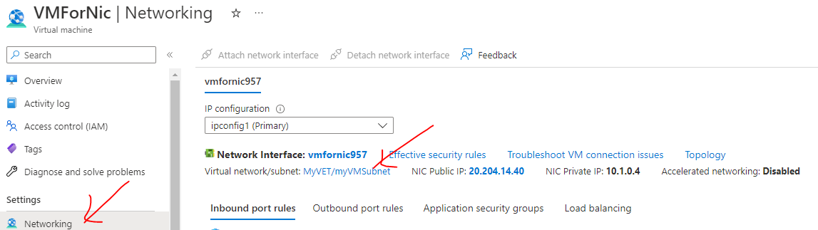

|  |  |
| --- | --- |
|  | * Networking 🡪 Network Interface 🡪 Disassociate. This will disassociate the NSG from the VNIC * Once it is disassociated – The VM will be open for all request – as there is no NSG rule associated to it. |

1. ATTACHING AND DETACHING NSG

|  |  |  |  |
| --- | --- | --- | --- |
|  | * As the NSG is a separate resource – it can attach and detached form Network interface / Subnet * On the same note, being a separate resource – If we have NSG attached to NIC – we can detach it from NIC and attach the same on Subnet and vice versa * As shown below | | |
|  | | | 1. Step 1 - NSG ATTACHED TO NIC |
|  | | STEP 2: DISASSOCIATE THE NSG FROM NIC | |
|  | | | STEP 3: ATTACH TO THE SAME NSG TO SUBNET |
|  | | | |

### COMMUNICATION WITH VIRTUAL NETWORKS

* The virtual network is isolated network in the cloud, hence by default there is no communication can happen between the VNETS
* The communication between VNETS can be done using ***VNET PEERING*** – where the VNETS can be either with a same region or different region
* The traffic between virtual machines in peered virtual networks uses the **MICROSOFT BACKBONE INFRASTRUCTURE** not via internet
* ***In a peered VNET – the VMs can communicate using their private IP – even If they belong to a different region. They don’t need any public IP***
* We can also peer virtual networks that are located across different subscriptions.
* The virtual networks can't have overlapping CIDR blocks

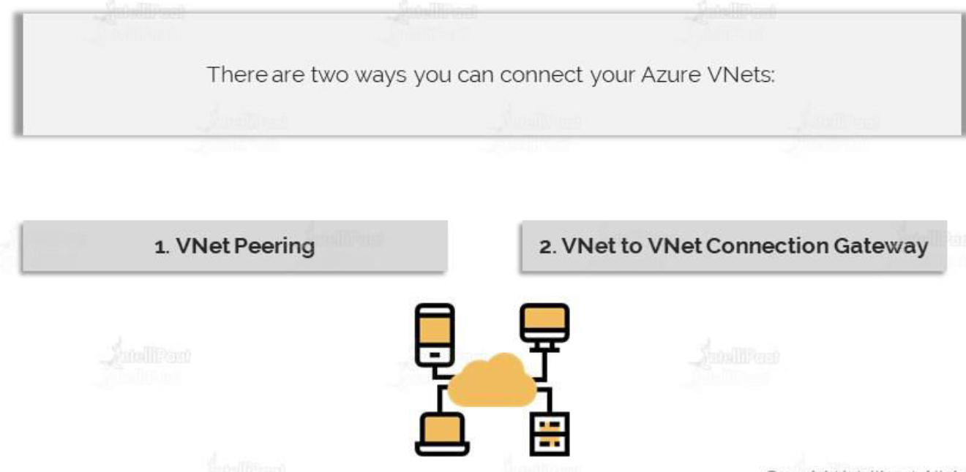

#### VIRTUAL NETWORK PEERING

Azure supports the following types of peering:

* **VIRTUAL NETWORK PEERING**: CONNECTING VIRTUAL NETWORKS WITHIN THE SAME AZURE REGION.
* **GLOBAL VIRTUAL NETWORK PEERING**: CONNECTING VIRTUAL NETWORKS ACROSS AZURE REGIONS.

|  |  |
| --- | --- |
|  |  |
| **VNET PEERING NOT TRANSITIVE** | * If the VNET peering has been done between Region 1 🡪Region 2 and between Region 2🡪 Region 3 . Then doesn’t mean that a VM from Region 1 can able to communicate to a VM in Region 3 * A separate peering has to be done for this communication between Region 1 and Region 3 |

##### SETTING UP VIRTUAL NETWORK PEERING

|  |  |
| --- | --- |
|  | * Step 1 – Create 2 VMs which will be part of 2 different VNET. * Note – To validate the communication between VM in different VNET * Install IIS on the 1st VM(stagingvm) * After peering - login to testVm (using RDP) and access the ISS of stageVm via its private IP |

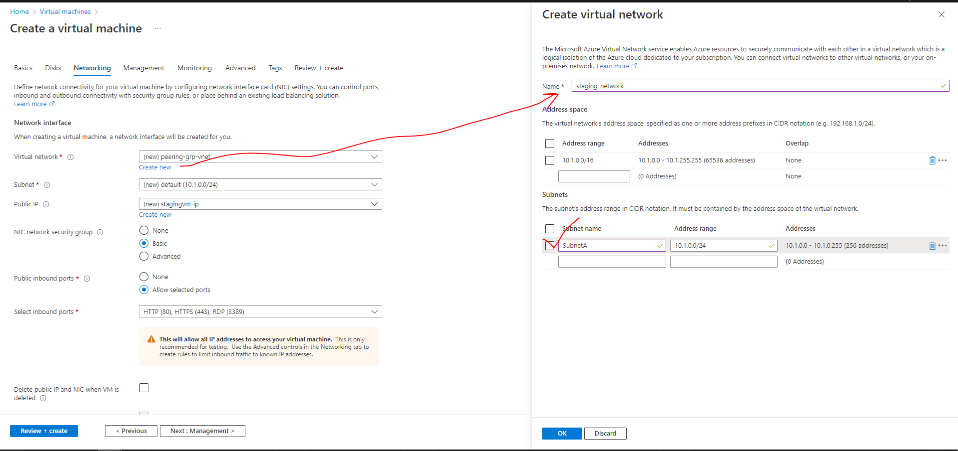

###### PEERING THE VNETS

* In peering configuration – we need create the link from both sides. This will allow cross communication between the virtual machines and both of the networks.
* Go to either of the Vnet 🡪 Peering 🡪 Add (This configuration will establish cross peering between VNets )

|  |  |
| --- | --- |
| Peering link name | We need to provide 2 peering link name one from each VNET |
| Virtual Network | Since we are on Staging network – hence the VNET we want to establish the peering has been provided i.e., “test-network” |

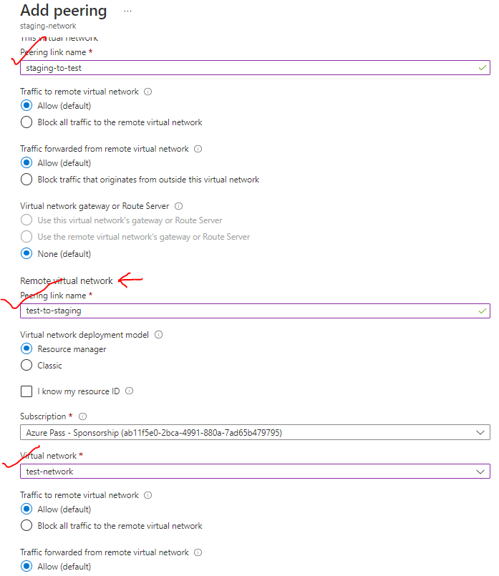

PEERING ESTABLISHED

STAGE TO TEST

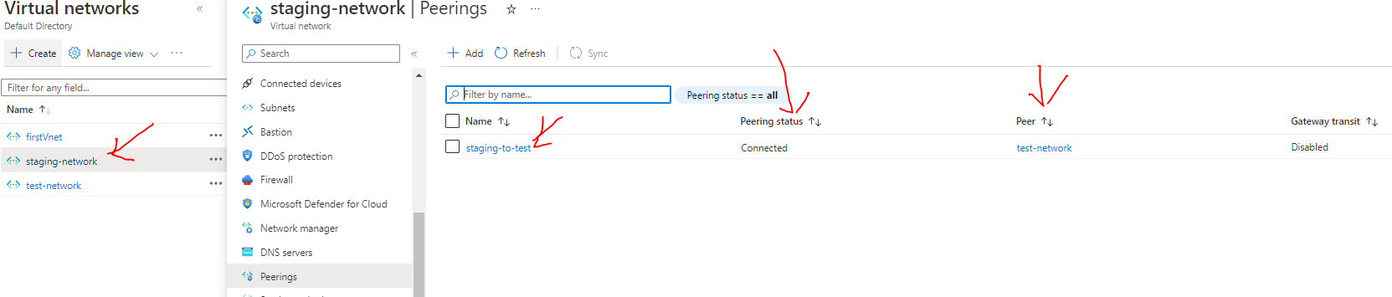

TEST TO STAGE

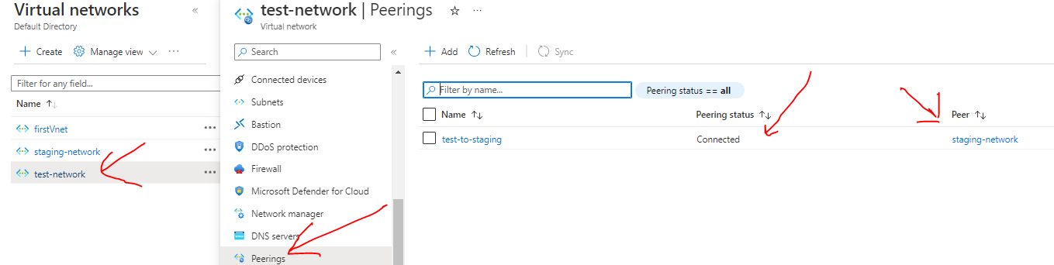

* **After peering RDP to testvm 🡪 Access the IIS using the private IP of stagevm**

#### VNET TO VNET CONNECTION USING GATEWAY DEVICE

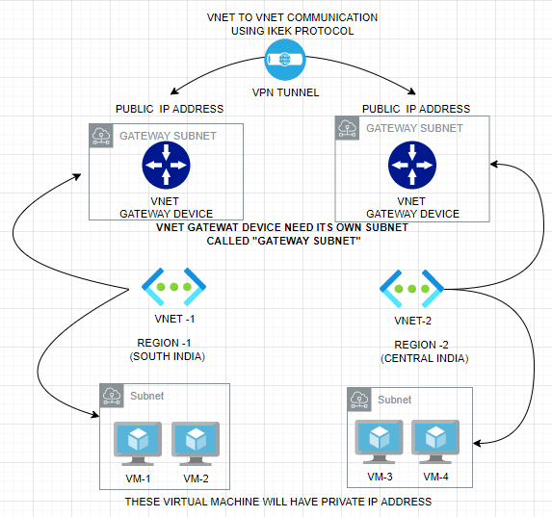

* In VNET-to-VNET connection using gateway device. We need to deploy a VNET gateway device on both VNETs
* The VNET requires, its own a dedicated Subnet – which we refer as **Gateway Subnet**
* When we deploy a VNET gateway device it will have a Public IP address (static IP address) associated with it, by default
* Between these Virtual Gateway device – we establish a VPN Tunnel. The protocol used for this communication is **IKEK**
* Now the VMs in VNET-1 and VNET-2 can be able to communicate with each other via VPN connection(tunnel) using their private IP address.

##### SETTING UP GATEWAY COMMUNICATION

1. STEP 1: Create 2 V-NETS -Let’s say in two regions (Central India and Central US). While creating the VNET – a default subnet is also created where we will deploy the VMs.
2. STEP 2: While creating the V-NET make sure we select different IP address range for both the VNETs

|  |  |
| --- | --- |
| **VNET -1**  **(CENTRAL INDIA)** |  |
| **VNET -2**  **(CENTRAL US)** |  |

1. STEP 3: VNET CREATED

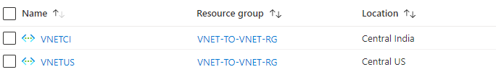

1. STEP 4: DEPLOYING A GATEWAY SUBNET

* To deploy the Gateway subnet 🡪 Navigate to Corresponding subnet

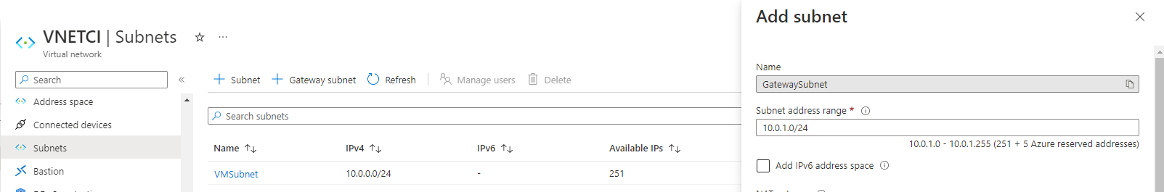

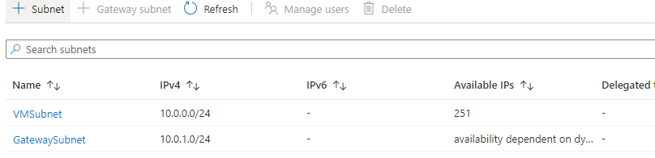

1. STEP 5: DEPLOYING VITUAL NETWORK GATEWAY DEVICE

We need to deploy gateway device in both the Virtual networks. As shown below

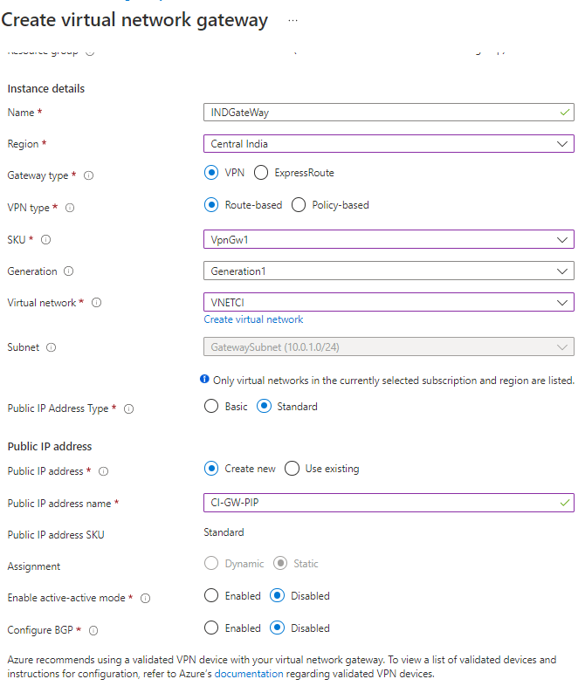

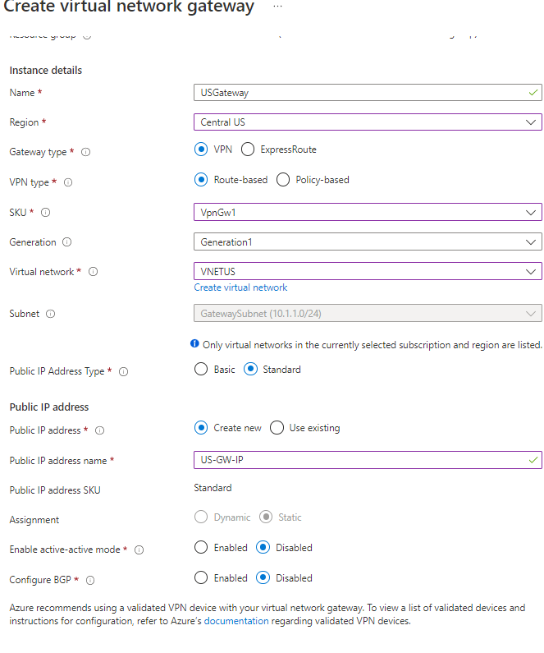

1. STEP 6: DEPLOYING VM IN THE VNET

* ***We create VM in a subnet – as the communication will happen using private IP -hence we don’t need have public address***

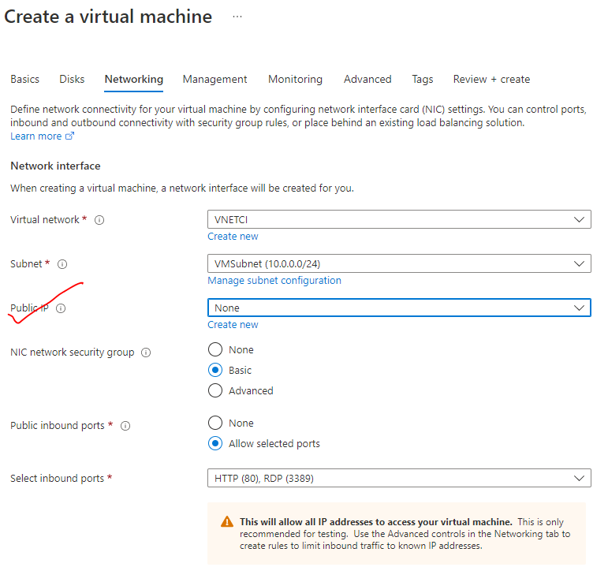

#### VPN (VIRTUAL PRIVATE NETWORK)

|  |  |
| --- | --- |
| How Does a VPN Work Illustration | * VPN are used to create a private network. The data is transmitted through an encrypted tunnel over the internet. * The VPN client software on our computer encrypts the data traffic and sends it to the VPN server through a secure connection. The data goes through the ISP, but it’s been so scrambled because of the encryption, they can no longer decipher it. * The encrypted data from our computer is decrypted by the VPN server. The data is then sent to the internet and receives a reply that’s meant for us. The traffic is then encrypted again by the VPN server and is sent back to us. * The VPN client on your device will decrypt the data so you can understand and use it. |

#### TYPES OF VPN CONNECTION

##### SITE TO SITE VPN CONNECTION

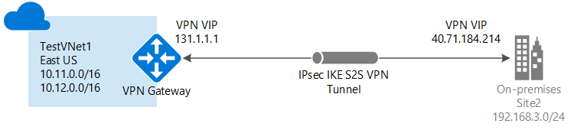

* It’s a VPN connection between two different site i.e S2S connections are used when we want to connect an entire on premises network onto as the virtual network.
* As it’s a VPN connection , it’s is a private communication(using private IPs of the resources) between the sites via a virtual tunnel usinf IKEK protocol.

##### POINT TO SITE VPN CONNECTION

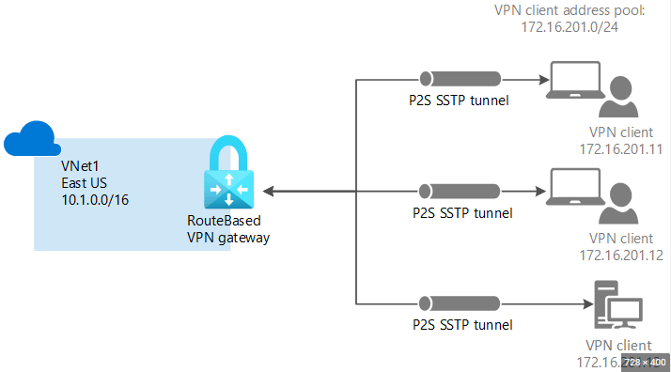

* **A Point-to-Site (P2S) VPN gateway connection lets you create a secure connection to the virtual network from an individual client computer. A P2S connection is established by starting it from the client computer.**
* This solution is useful for telecommuters who want to connect to Azure V-Nets from a remote location, such as from home or a conference. P2S VPN is also a useful solution when we have only a few clients that need to connect to a V-Net.
* So- a secure connection is first made from the client machine onto a virtual network. And then via that VPN connection, we can then use the private IP address of the Azure virtual machine for the communication. Hence we don’t need a public IP address of the VM

|  |  |
| --- | --- |
| **POINT TO SITE CONNECTION** | **SITE TO SITE CONNECTION** |
| 1. P2S connection can be used when small number of clinet machines has to connect with the VNET. | 1. S2S connections are used when we want to connect an entire on premises network onto as the virtual network. |

## AZURE BASTION SERVICE

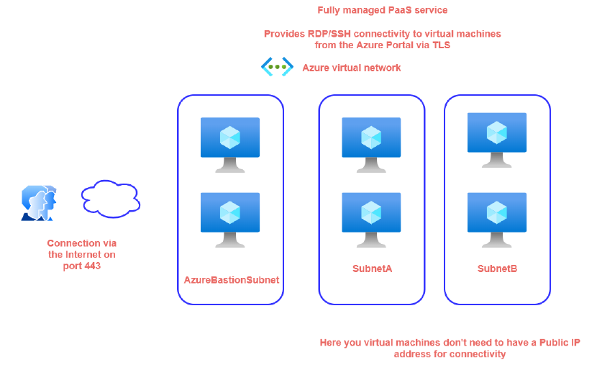

* In a virtual network, if we have VMs that are part of different subnets. To connect with them we need to allocate a public IP address on each VM. But in certain use cases, where we might not prefer to assign public IP to VMs while running internal workloads – which we do not want to expose to the public internet. The bastion helps us to connect with the VM without assigning a public IP to the VMs
* Azure Bastion is a service, lets us connect to a virtual machine using browser and the Azure portal, or via the native
* SSH or RDP client already installed on the local computer.
* The Azure Bastion service is a fully platform-managed **PaaS** service that we provision inside the virtual network. It provides secure and seamless **RDP/SSH connectivity to the virtual machines directly from the Azure portal over TLS**.
* *When we connect via Azure Bastion, the virtual machines don't need a public IP address*
* **Using Azure Bastion protects the virtual machines from exposing RDP/SSH ports to the outside world, while still providing secure access using RDP/SSH.**
* When we use this service, it's going to creates its own compute machines that are going to be responsible
* for establishing the connectivity. All the compute machines are managed by Azure itself.
* The compute has to be part of a separate subnet in our virtual network. The name of the subnet named as “***AzureBastionSubnet***”

### SETTING UP BASTION SERVICE

STEP 1: CREATE A VM